**Download and Install Tableau Public**

**Downloading Tableau Public**

Let's look at the downloading steps for Tableau Public:

1. To download Tableau Public, visit the Tableau Software website at

<https://www.tableau.com/en-gb/products/public/download>



2. Click on DOWNLOAD THE APP



3. You will see the above page. When you click on DOWNLOAD THE APP, it will ask you to sign up first.

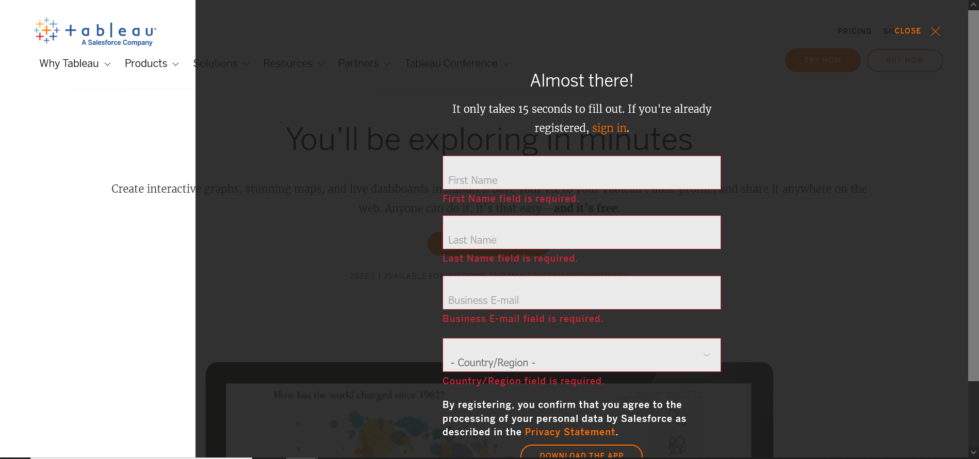

3. Once signed in, the download begins, you will see the following screen.

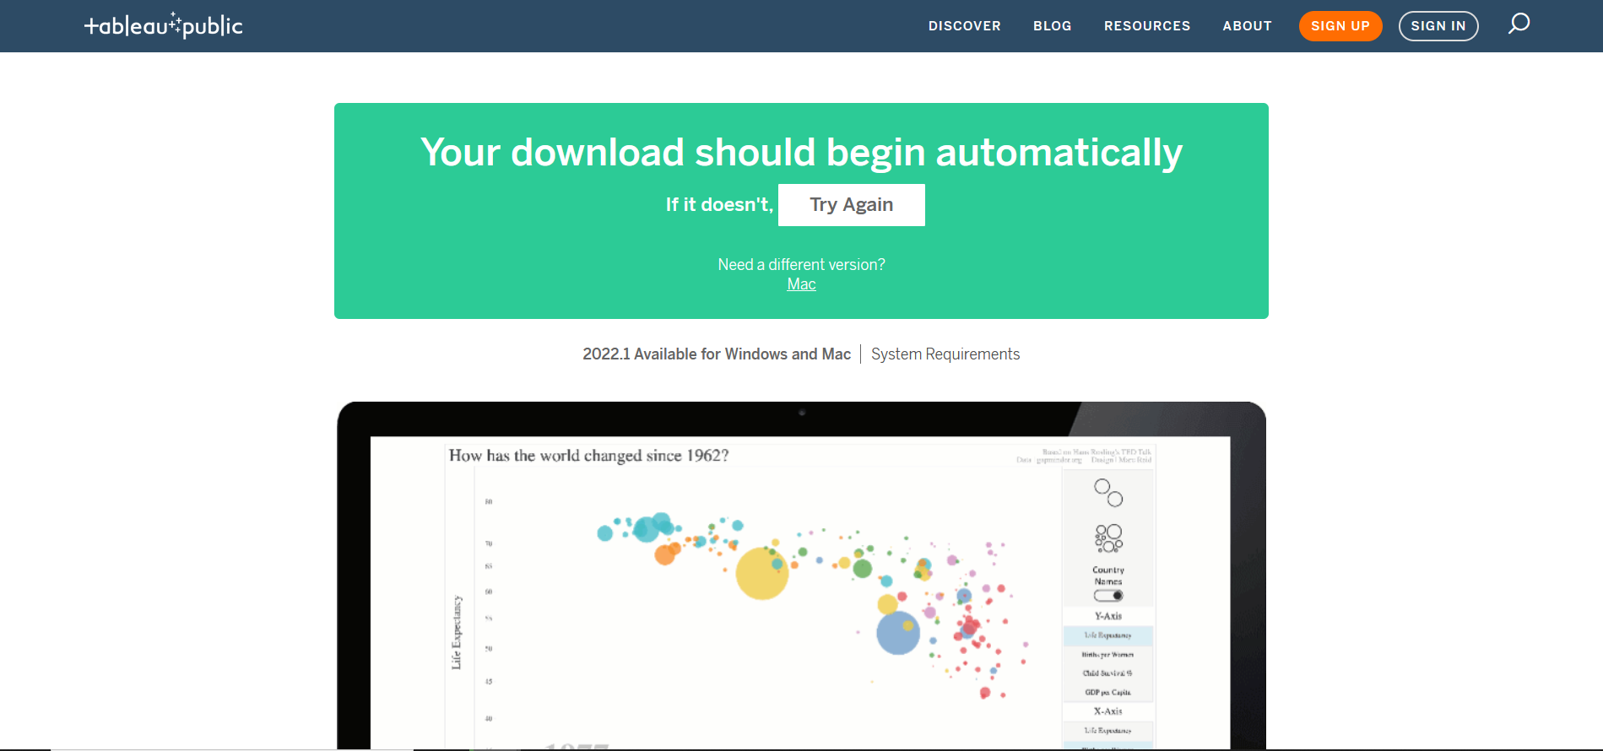

4. The version of Tableau Public that downloads automatically is the 64-bit version for Windows.

Users of Mac should download the appropriate version for their computers, and users

with 32-bit Windows machines should download the 32-bit version.

**Installing Tableau Public**

1. Double click the downloaded file.

E.g., TableauPublicDesktop-64bit-2022-1-1

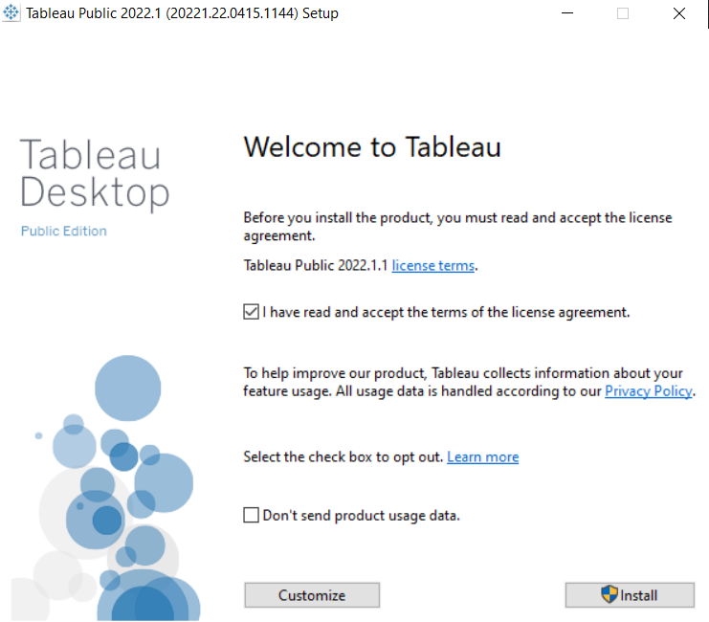

1. Click Install

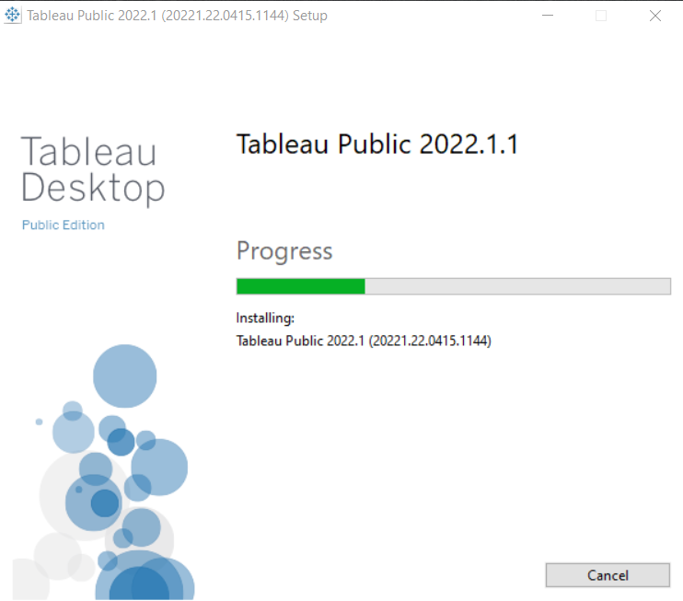

1. When installation completes, Tableau Desktop Public will be launched automatically.

